User Guide

# Configure an application

All configurations are stored in the **config.py** file in the root directory of the application. To change a configuration, go to that file. You will see something like following:

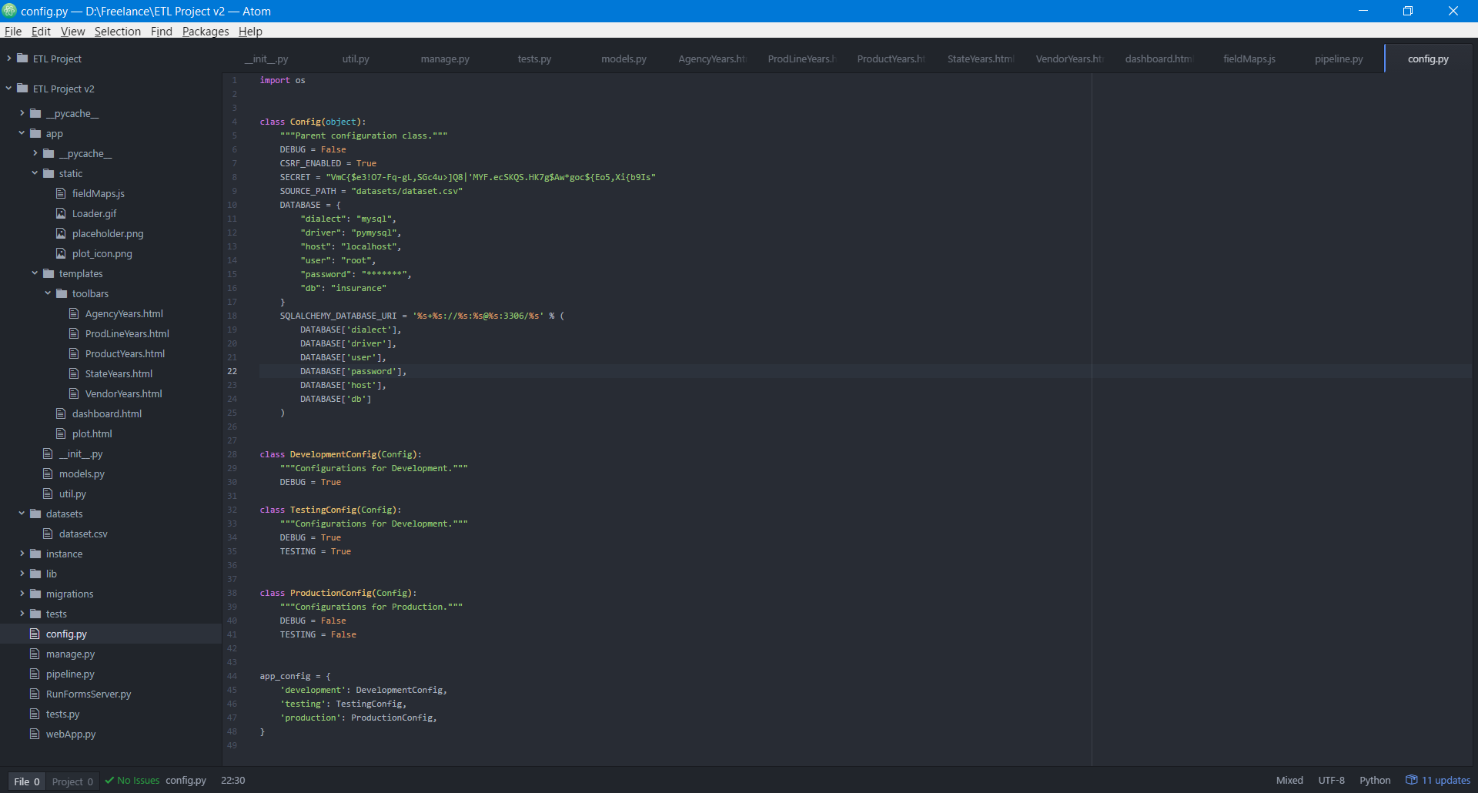

To change where the pipeline script loads the CSV dataset, modify **SOURCE_PATH** parameter. To change the database connection, modify **DATABASE** parameter. If you want to have different parameters for different environments, just simply override parameters for specific environment under the corresponding class declaration in **config.py**.

# Pipeline process

To load data from CSV into the database, execute following script:

* **python pipeline.py**

In case of successful execution you will see following output:

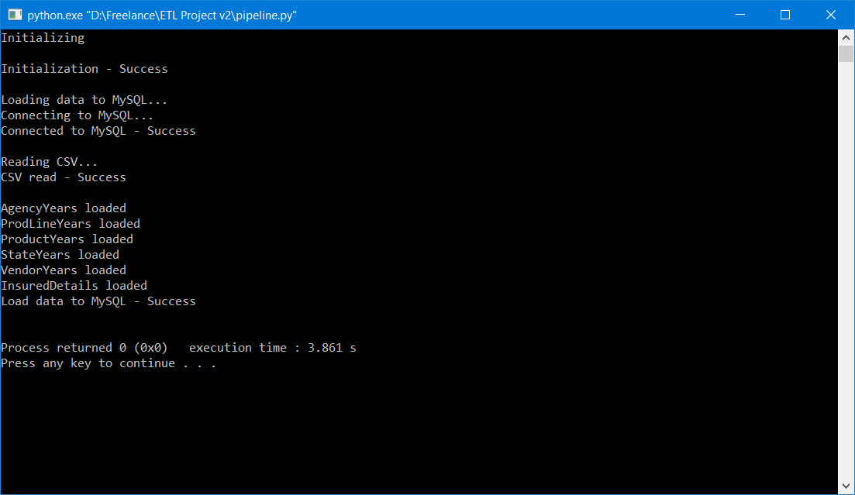

# Start a web server

To start a web application, simply run following commands in your terminal:

* **python webApp.py &**
* **disown**

Now, go to your server IP address in your browser, you should be able to see following screen:

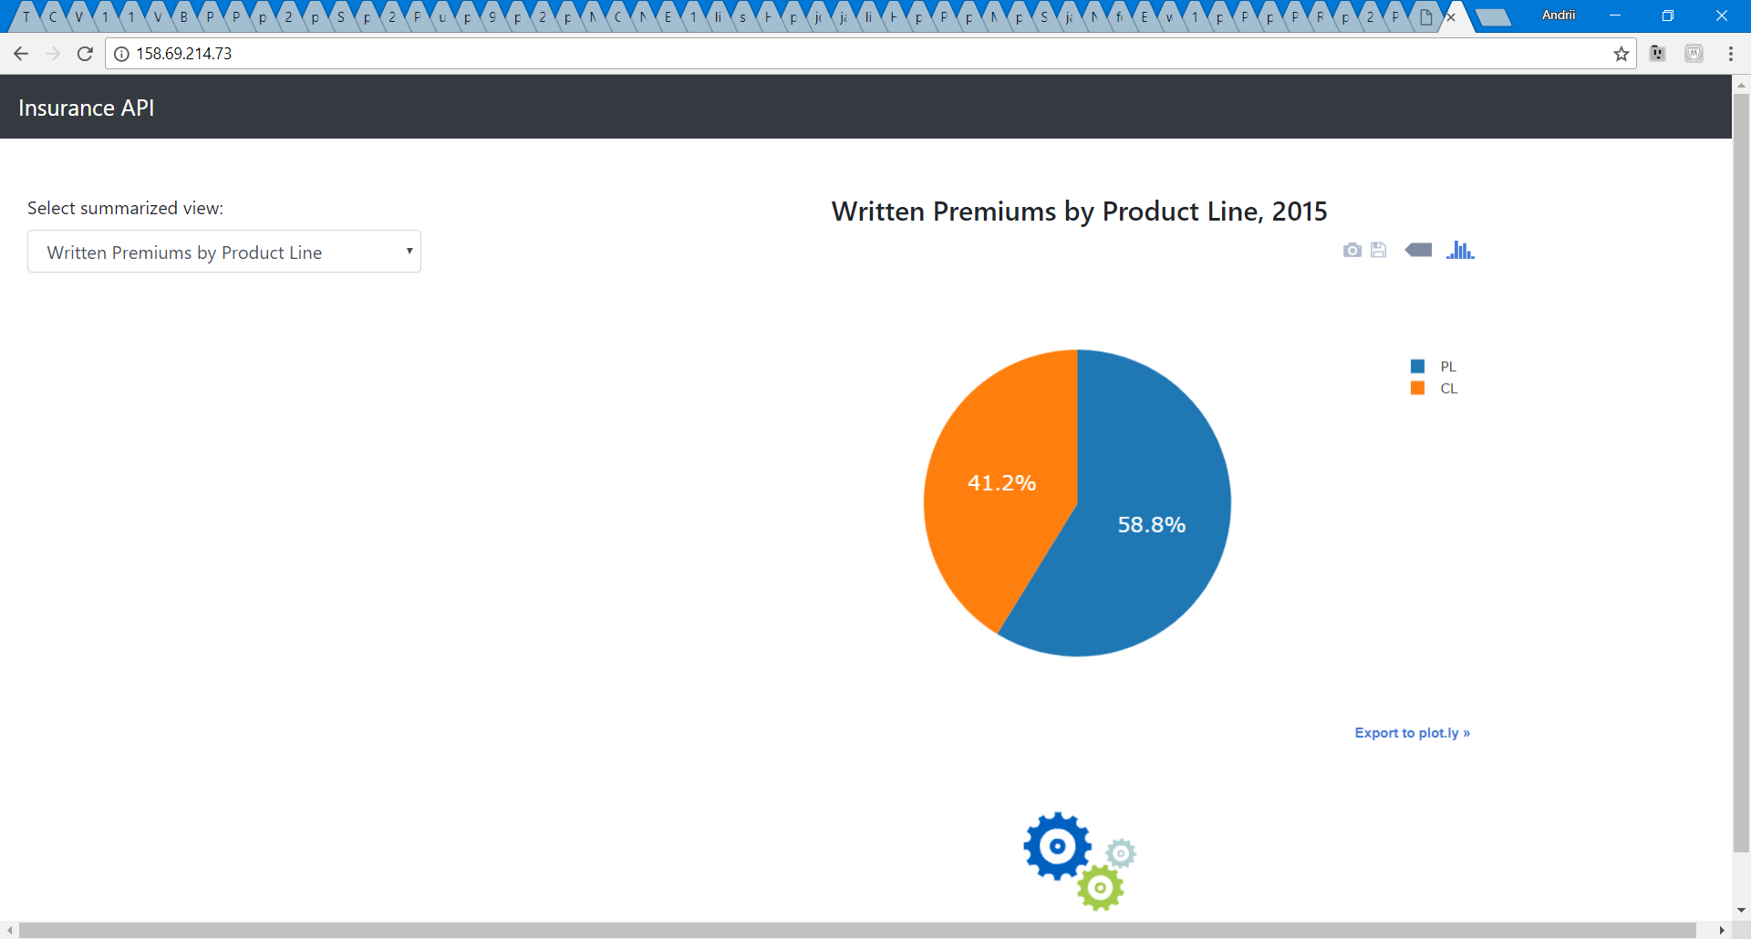

# Selecting different summarized views

On your web page you are able to select one of the following summarized views in the left bar:

* Written Premiums by Agency Years
* Written Premiums by Product Lines (default)
* Written Premiums by Product
* Written Premiums by State
* Written Premiums by Vendor

After selecting specific summarized view, chart and data table will be loaded into the main panel of the dashboard.

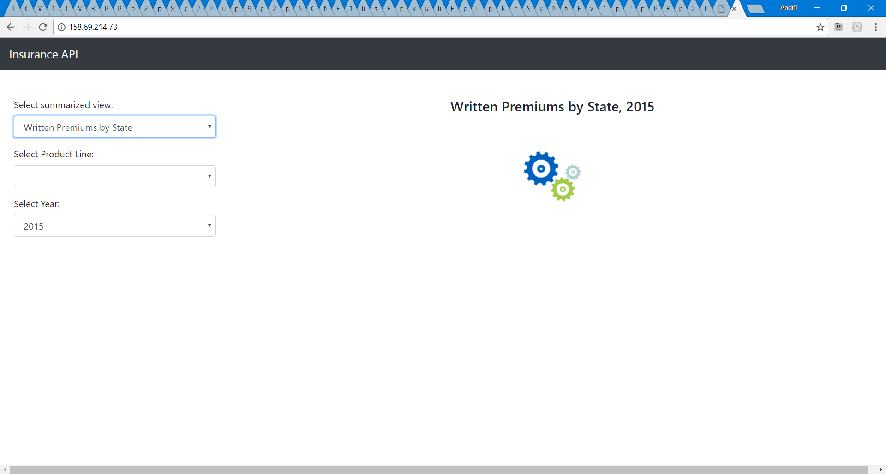

When choosing different years, chart and data table will be reloaded to display appropriate year information. When selecting any other filter, different from Year, only data table will be reloaded.

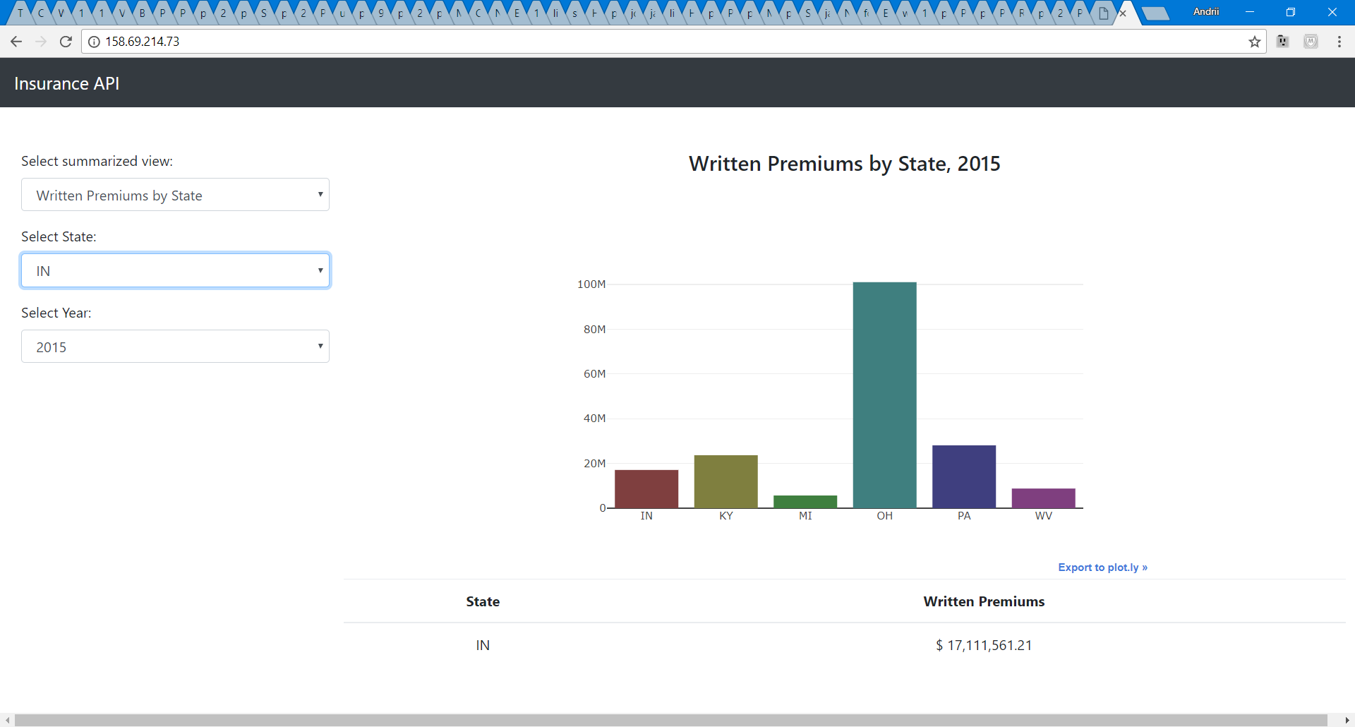

# Running unit tests

To run a unit tests on the application run the following command:

* **python tests.py**

You should be able to see the unit test results now. By default tests script checks all the APIs, making sure they are accessible and returns information.

